MACH4METAL

Metalworking machinery
Transito 21,
6909 DA BABBERICH
Netherlands
Tel. +31 (0)316 – 247123
Fax. +31 (0)316 - 247956
info@mach4metal.com
www.mach4metal.com

Account No: 66.52.13.883
IBAN : NL33 INGB 0665 2138 83
BIC : INGBNL2A

CME Lateral milling with boring spindle
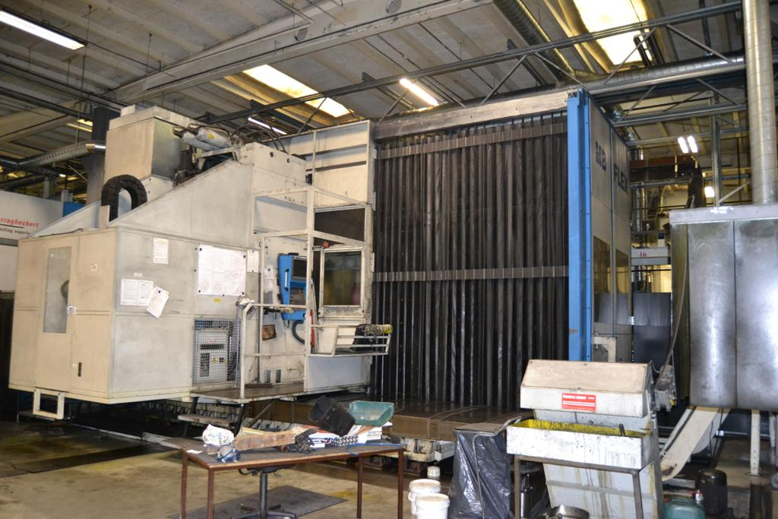
- Make : CME Spain
- Type : MB FLEX 3000
- YOP : 2006
- No : 130 + 129

- Working area
- X Travel : 3.000
- Y Travel : 2.000
- Z Travel : 1.500
- W Travel : 1.200
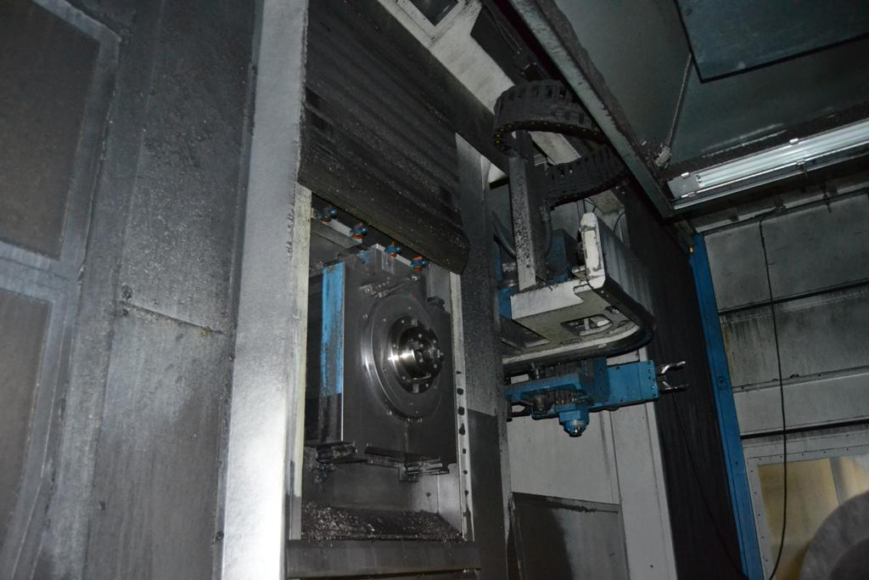
- Table size : 1.500 x 1.500
- Table load : 5.000
- Full B Axis : 0.001 Gr.

- Spindle taper : Bt 50
- Ram size : 580 x 430
- Boring spindle : Ø 150
- Power : 41 kW
- Speeds : 50 – 2.200

- Chain ATC 60 positions
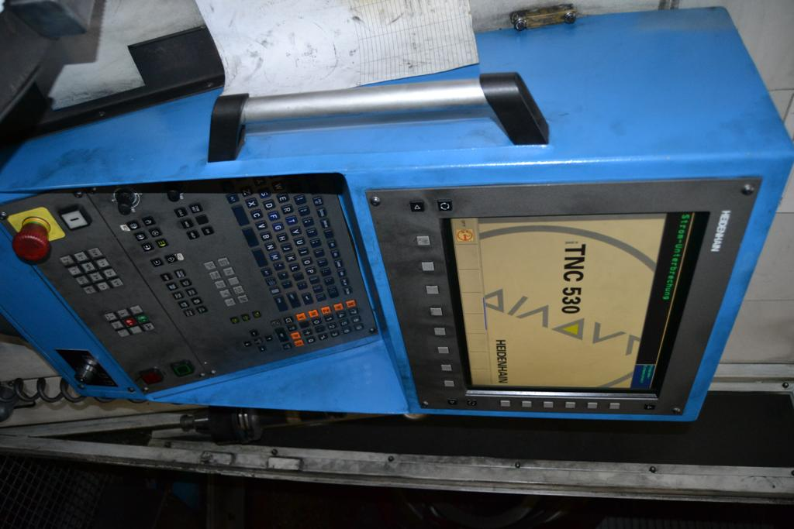
- Incl. chip conveyor
- Incl. Internal coolant 60 Bar

- Incl. iTNC 530 Control
- Incl. Blum tool measurement
- Incl. Marposs measuring probe
- Hours machine 130 = 8200 & 9020 H

Note: The above information has been obtained to the best of our ability and belief from, and from the manufacturers where possible. It is given in good faith, but its accuracy can not be guaranteed. Accordingly, it will not form a representation or constitute contractual terms. We advise you to check any vital details!

